Lab 6: URL Filtering
Name:
Jobayer Bhuiyan
Purpose:
The purpose of this lab is to configure URL filtering on a Palo Alto firewall using a custom URL category. The lab demonstrates how to block or allow specific websites using a security policy and how to verify that the policy is working using firewall logs.

Logical Drawing:
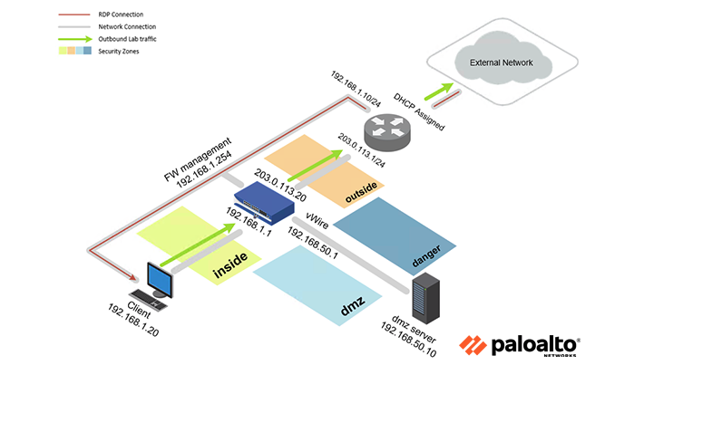

Address Table:
Device | Interface | IP Address | Description
Client | N/A | 192.168.1.20 | Lab User System
Firewall | Management | 192.168.1.254 | Web GUI Management
DNS Server | N/A | 1.1.1.1 or 8.8.8.8 | External DNS Server

Procedures:
- Access the Firewall
Log into the firewall via web browser at https://192.168.1.254 using credentials:
  - Username: admin
  - Password: Pal0Alt0!
- Create a Custom URL Category
  - Navigate to: Objects > Custom Objects > URL Category
  - Click Add
  - Name: news-sites
  - Add the following URLs:
    - cnn.com, *.cnn.com
    - bbc.com, *.bbc.com
    - foxnews.com, *.foxnews.com
  - Click OK and Commit
- Create a Security Policy to Block News Sites
  - Go to: Policies > Security
  - Click Add
  - Name: Custom blocking policy
  - Source Zone: inside
  - Destination Zone: outside
  - Application: any
  - Service/URL Category: select news-sites
  - Action: Reset both client and server
  - Log at Session End: enabled
  - Click OK and Commit
- Verify Policy Functionality
  - Try visiting cnn.com, foxnews.com, and bbc.com — they should be blocked
  - Try visiting google.com — it should work
  - If blocking fails, move your custom rule above the egress-outside-contentID rule
  - Commit again and re-test
- Check Logs
  - Navigate to Monitor > Logs > Traffic
  - Look for entries showing your custom rule being used to block traffic

Verification / Troubleshooting:

Step | What to Check | Device | Expected Result
1 | Browser login | Client | Successfully logs into firewall GUI
2 | URL Category created | Firewall | news-sites category includes correct domains
3 | Rule applied correctly | Firewall | Rule use URL category and proper action
4 | Test blocked site | Client | cnn.com, bbc.com, foxnews.com show connection reset or fail
4 | Test allowed site | Client | google.com loads successfully
5 | Traffic logs | Firewall | Show rule name = Custom blocking policy

License Activation (if needed):
If the lab requires license installation, go to Device > Licenses > Activate Feature and enter the code: I2798686. Reconnect after activation.

